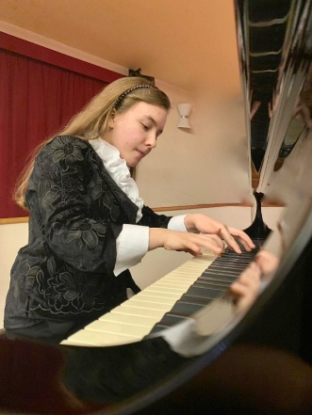
Participants

JUNIOR CATEGORY

1. Bleve, Chiara (20. 12. 2006), Italy
Music School “A. Corelli” - Vittorio Veneto, Italy
Teacher: Giorgio Lovato

L. v. Beethoven Sonata Op. 10 No. 3 – 1st. mvt.: Presto (5’20”)
I. Albéniz Sevilla, from Suite espagnole Op. 47 No. 1 (4’40”)
M. Moszkowski Etude, Op. 72 No. 2 (2’05”)
M. Ravel Sonatine – 3rd mvt.: Animé (4’)
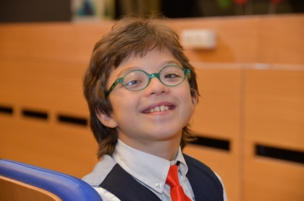
R. Muczynski Desperate measures Op. 48 (8’30”)

2. Glavinic, Mattias Antonio (23. 07. 2009), Italy
Conservatorio di Musica Benedetto Marcello - Venice, Italy
Teacher: Gianluigi Polli

W. A. Mozart Sonata in D major K 311 - 1st mvt.: Allegro con spirito (3’30’’)
L. v. Beethoven Sonata No. 10 in G major Op.14 No. 2 - 1st mvt.: Allegro (5’50’’)
F. Chopin Polonaise in G-sharp minor (Op.posth.) (6’40’’)
F. Chopin Grand Waltz Brilliante in A minor Op. 34 No. 2 (5’50’’)
H. Villa Lobos O Polichinelo (1’40’’)
3. Grigoryan, Petro (01. 01. 2007), Ukraine
Kyiv Children's School of Arts No.2 M.I.Verikivsky
Teachers: Tatyana Ivaschenko & Luiza Grigoryan

W. A. Mozart Sonata No. 10 in C major K. 330 - 1st mvt.:
Allegro moderato (6’)
E. Lecuona Malagueña (4’)
C. Debussy Clair de Lune (6’)

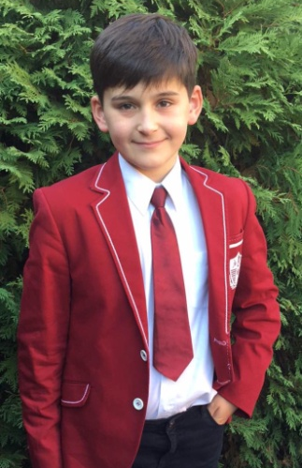

4. Kozyak, Hanna (22. 12. 2006), Ukraine
Solomiya Krushelnytska Specialised Music School, Lviv, Ukraine
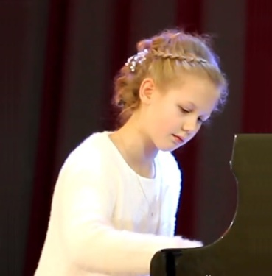
Teacher: Oksana Rapita

L. v. Beethoven Sonata in G major, Op. 79 No. 25, 1st mvt. - (3’)
S. Bortkiewicz Etude, Op. 15 No. 9 - (2’10’’)
E. Granados Spanish dance No. 5, Andaluza - (3’40’’)
M. Moszkowski Sparks, Op. 36 No. 6 - (3’)
F. Chopin Fantaisie-impromptu, Op. 66 - (6’)

5. Mazor, Eden (1. 01. 2006), Israel
Ramat Gan Conservatory, Ramat Gan, Israel
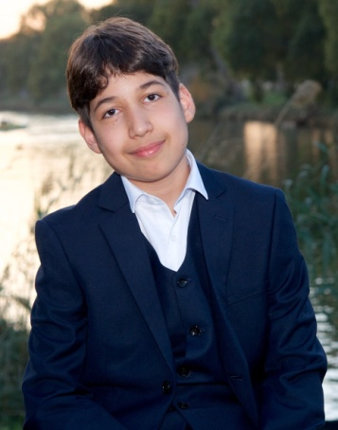
Teacher: Marina Gershman

C. Czerny Etude No. 13 in B major, Op. 740 - (2’05’’)
J. S. Bach Prelude & Fugue, WTC-I, No. 18 in G-sharp minor,
BWV 863 - (4’25’’)
I. Albéniz Suite Española No.1, Op. 47 : "Granada" - (4’25’’)
L. v. Beethoven Sonata No. 18 in E-flat major, Op. 31, 1st mvt. - (6’20’’)
F. Mendelssohn-Bartholdy Rondo Capriccioso in E major, Op. 14 (6’20’’)

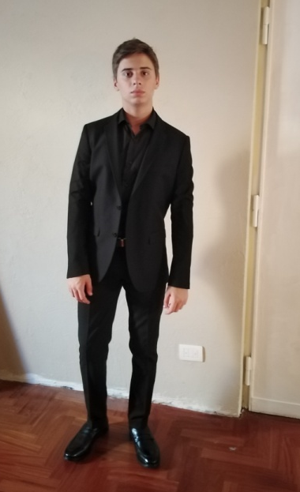
7. Pomposelli, Matteo (23. 02. 2005), Italy
European Arts Academy Aldo Ciccolini, Trani, Italy

Teacher: Alfonso Soldano

F. Chopin Scherzo, Op. 54 No. 4 - (11’36’’)
I. Albéniz El albaicín, from Iberia - (7’)
F. J. Haydn Sonata in C major, Hob XVI 50, 1st mvt.- (5’20’’)

8. Tomić, Magdalena (13. 09. 2007), Serbia
Mokranjac Music School, Belgrade, Serbia
Teacher: Katarina Sandorov

P. Faulhaber Salonpolka - (3’30’’)
E. Pozzoli Pinocchio - (4’30’’)
J. Turina El Niño se duerme - (3’)
L. v. Beethoven Six Variations - (5’)

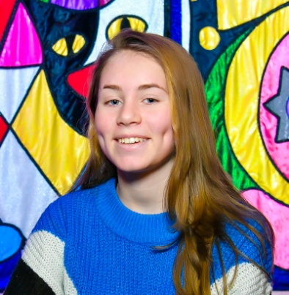
9. Zhuravleva, Maria (03. 08. 2005), Russia
Dzerzhinsk Music School, Dzerzhinsk, Russia
Teacher: Alla Alkaceva

W. A. Mozart Sonata No. 13 in B major, K. 333, 1st mvt. - (5’20’’)
E. Lecuona Malagueña - (3’45’’)
P. I. Tchaikovsky Andante maestoso - (5’)

YOUNG CATEGORY

1. Brezič, Mina (25. 06. 2001), Slovenia
Music School, Celje, Slovenia
Teacher: Aleksandar Serdar

L. v. Beethoven Sonata Op. 53, Waldstein, Allegro con brio - (8’43’’)
E. Granados Spanish dance No. 5 - (32’5’’)
F. Liszt Sonetto del Petrarca 104 - (6’10’’)
F. Liszt Madžarska rapsodija 11 - (6’30’’)

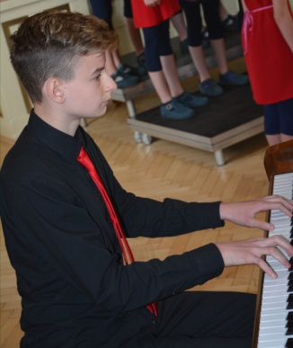
2. Cergol, Tim (09. 05. 2004), Slovenia
High School for the Arts, Velenje, Slovenia
Teacher: Aleksandar Serdar

F. Mendelssohn-Bartholdy Fantasie in F-sharp minor, Op. 28, Con moto agitato,
Allegro con moto, Presto - (15’)
F. J. Haydn Sonata in B minor, No. 47, Hob.XVI/32, Allegro moderato - (5’)
E. Granados Spanish dance No. 2 & No. 5 - (6’30’’)
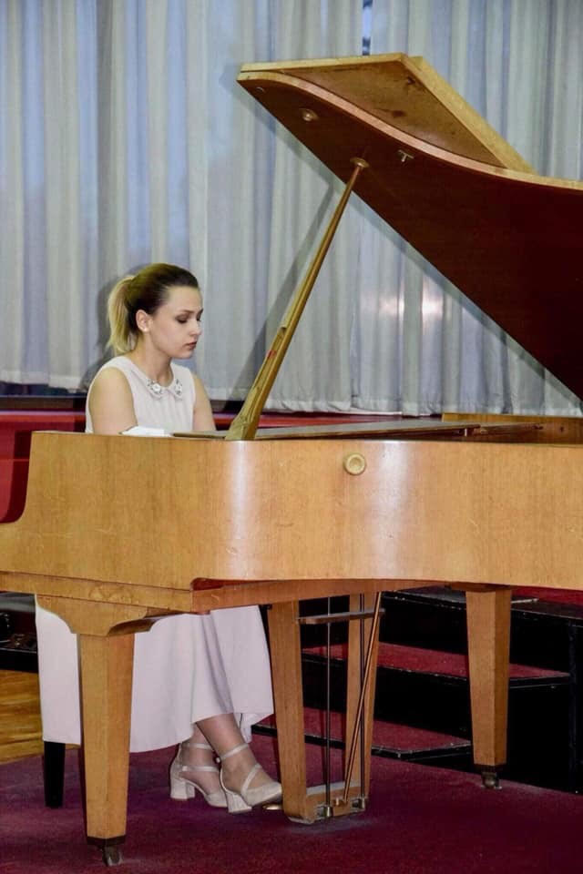
3. Nikolovska, Angela (23. 11. 2001), North Macedonia
DMBUC Ilija Nikolovski-Luj, Skopje, North Macedonia
Teacher: Gligor Gelebesev

L. v. Beethoven Sonata, Op. 31 No. 3, 1st mvt. - (6’40’’)
F. Schubert Impromptu, Op. 90 No. 4 - (7’30’’)
F. Liszt Paraphrase on Verdi's Rigoletto - (8’)
E. Granados Spanish dance No. 5, Andaluza - (3’30’’)
A. Ginastera Argentinian dance No. 3 - (3’30’’)

4. Park, Hyunmin (17. 04. 2002), Korea
Prayner Konservatorium, Vienna, Austria
Teacher: Filimon Ginalis
J. Haydn Sonata in C major, Hob. XVI/48, No. 58, 2nd mvt. - (3’)
Manuel de Falla Danza del terror - (2’)
M. Mussorgsky Pictures at an Exhibition - (30’)

5. Prosi Rejsi (18. 03. 2001), Albania
Teacher: Etrita Ibrahimi
I. Albeniz Pavana-Capricho, Op. 12 - (3’20’’)
F. Chopin Etude, Op. 25 No. 11, Winter wind - (3’53’’)
L. v. Beethoven Sonata in D major, Op. 15 No. 28, Pastorale, 1st mvt. - (6’46’’)
J. S. Bach Prelude & Fugue, WTC:II,No. 5 in D major, BWV 874 - (5’45’’)
T. Simaku Hommage a Debussy (pas des chromatiques) - (7’30’’)
F. Liszt Hungarian Rhapsody No. 10 in E major - (5’30’’)

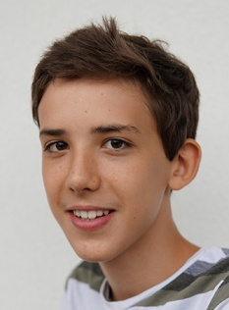

6. Weller, Markus (21. 05. 2004), Austria
Kunstuniversität, Graz, Austria
Teacher: Zuzana Niederdorfer
E. Granados Allegro de Concierto, Op. 46 - (8’)
J. Haydn Sonata in D major, Hob. XVI No. 37, 1st mvt., Allegro con brio - (3'50’’)
O. Messiaen Vingt Regards Sur l'Enfant Jésus No. XI: Première communion de la Vierge - (6’10’’)
F. Liszt Ballade No. 2 in B minor - (15’)

MAJOR CATEGORY

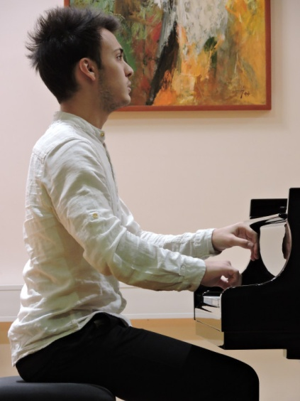
1. Arsov, Darko (20. 05. 1997), North Macedonia
Academy of Music, Ljubljana, Slovenia
Teacher: Vladimir Mlinarić

First Stage

L. v. Beethoven Sonata Waldstein, Op. 53, 1st mvt. - (8’30’’)
I. Albeniz Asturias - (5’)
F. Chopin Etude Op. 25, No. 10 - (4’30’’)

Final Stage

L. v. Beethoven Sonata Waldstein, Op. 53, 2nd & 3rd mvt. - (14’)
F. Chopin Etude Op. 10, No.1 - (2’)
F.Chopin Mazurka in B minor, Op. 33 No. 4 - (5’)
F.Liszt Hungarian Rhapsody No. 2. (With small cadenza by the same composer) - (10’)

2. Belova, Alla (09. 07. 1996), Russia
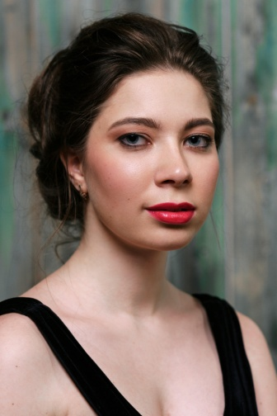
Rimsky-Korsakov Conservatory, Saint-Petersburg, Russia
Teacher: Aleksander Maslov

First Stage

W. A. Mozart Sonata in C major, KV330 - (6’)
R. Schumann Etude after Paganini Caprices, Op. 3 in A minor - (4’)
E. Granados Quejas, o La Maja y el Ruiseñor from Goyescas - (6’)

Final Stage

J. Brahms Intermezzo, Op. 118 No. 1 & 2 - (8’)
Ballade, Op. 118 No. 3 - (4’)
F. Schubert/ F. Liszt Liebesbotschaft - (3’)
Aufenthalt - (4’)
Gretchen am Spinnrade - (4’)
P. I. Tchaikovsky Chant Élégiaque, Op. 72 - (6’)
A. Grünfeld Soirée de Vienne, Op. 56 - (6’)
N. Rimsky-Korsakov/ The Flight of the Bumblebee - (2’)
K. Vilensky
3. Brajković, Sven (06. 02. 1999), Croatia
Music Academy in Zagreb, Croatia
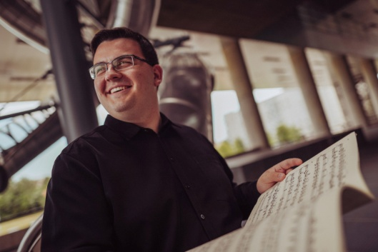
Teacher: Srđan Filip Čaldarović

Academy of Music Ljubljana, Slovenia
Teacher: Aleksandar Serdar

First Stage:

J. Haydn Sonata in E-flat major, Hob. XVI: 52 - I. Allegro - (5’)
F. Mompou Cancion y Danza No. 11 & No. 12 - (7’)
S. Rachmaninov Etude-tableux in D major, Op. 39, No. 9 - (4’)

Final Stage:
F. Chopin Nocturne in f minor, Op. 55, No. 1 - (5’)
F. Chopin Scherzo in E major, Op. 54 - (10’)
S. Prokofjev Sonata in B-flat major, Op. 83 - (18’)
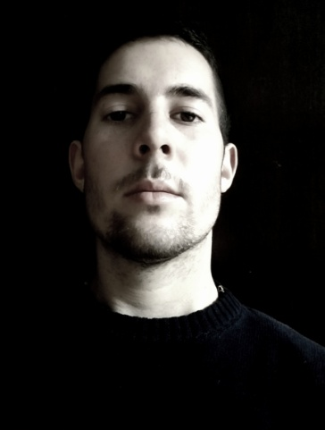
4. Ćućić, Alvin (25. 09. 1996), Croatia
Academy of Music, Ljubljana, Slovenia
Teacher: Hinko Haas

First Stage

F. Mompou Paisajes
La fuente y la campana - (3’30’’)
El lago (4’)
L. v. Beethoven Sonata Waldstein, Op. 53, 1st mvt. - (8’)
F. Chopin Etude in C major, Op. 10. No. 1 - (2’)

Final Stage

R. Schumann Faschingsschwank aus Wien, Op. 26 - (21’)
F. Chopin Scherzo in E major, Op. 54 - (11’)

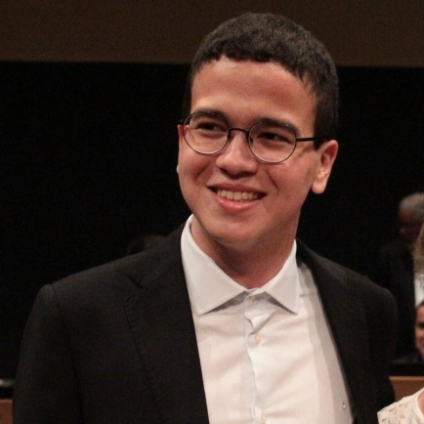
5. De Souza, Felipe (09. 01. 1995), Brasil
University of Music, Karlsruhe, Germany
Teacher: Fany Solter

First Stage

L. v. Beethoven Sonata, Op. 2 No.2, 1st mvt. - (5’)
F. Chopin Etude, Op. 10 No. 4 - (3’)
H. Villa-Lobos Impressoes Seresteiras - (5’)
A. Vieira Toccata - (3’)

Final Stage

W. A. Mozart Sonata in C major, K. 330 - (15’)
F. Liszt Ballade No. 2 in B minor - (14’)
M. Ravel Ondine, from Gaspard de la nuit - (7’)

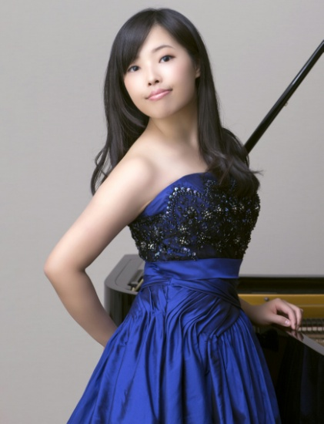
7. Inoue, Hinako (10. 03. 1997), Japan
Hanover University of Music, Drama and Media, Hanover, Germany
Teachers: Hironao Suzuki, Bernd Goetzke & Olivier Gardon

First Stage

F. Chopin Etude, Op.25 No. 6 - (2’30’’)
F. J. Haydn Sonata, Hob. 43, 1st mvt. - (5’)
H. Dutilleux Le jeu des contraires - (6’30’’)
A. Ginastera Sonata, Op.22 No.1, 1st mvt. - (4’)

Final Stage

J. S. Bach Prelude & Fugue, WTC: II, No. 13 in F-sharp major - (5’)
L. Janáček In the Mists - (15’)
S. Rachmaninoff Variations on a theme of Corelli, Op. 42 - (18’30’’)

8. Izawa, Miku (12. 05. 1995), Japan
Kunstuniversität, Graz, Austria
Teacher: Ayami Ikeba

First Stage

F.Chopin Etude Op. 10 No.4 - (2’)
L. v. Beethoven Sonata in E minor, No.27 Op.90, 1st mvt. - (5’30’’)
A. Ginastera Suite de danzas criollas, Op. 15 - (8’30’’)

Final Stage
F. Liszt Sonata in B minor, S. 178 - (30’30’’)
9. Jakabová, Marie (23. 06.1995), Czech Republic
Janáček Academy of Music and Performing Arts, Brno, Czech Republic
Teachers: Alena Vlasáková & Jan Jiraský

First Stage

S. Rachmaninov Etudes-Tableaux, Op. 33 No.4 in D minor -(3’38’’)
M. de Falla Danza ritual del fuego - (3’32’’)
J. Haydn Variations in F minor, Hob. 17/6 - (9’28’’)

Final Stage

D. Scarlatti Sonata in E major, K 380 - (2’26’’)
Sonata in D major, K 430 - (1’27’’)
F. Chopin Scherzo in B minor, Op. 20 No.1 - (10’29’’)
L. Janáček On an Overgrown Path: 1st Book
The Madonna of Frydek - (2’48’’)
Words Fail! - (1’32’’)
S. Prokofjev Sonata in F minor, Op. 1 No. 1 - (8’14’’)
B. Bartók Two Romanian Dances, Op. 8a - Allegro Vivace (5’24’’) Poco Allegro (5’03’’)

10. Jovović, Andrija (01. 10. 1998), Montenegro
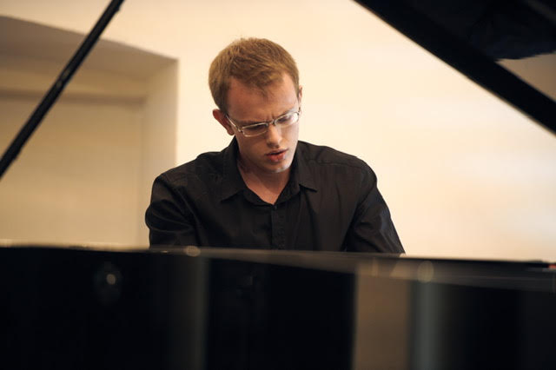
University of Music and Performing Arts, Mdw, Vienna, Austria
Teacher: Nataša Veljković.

First Stage

D. Scarlatti Sonata in E major, L224 - (3’30’’)
W. A. Mozart Sonata in C minor, KV. 457, 1st mvt - (4’30’’)
F. Mompou Canción y Danza No. 6 - (4’)
A. Scriabin Prelude Op. 9 for the left hand (2’30’’)
A. Scriabin Etude Op. 8 No. 12 - (2’30’’)

Final Stage

J. S. Bach Toccata in F-sharp minor BWV 910 - (12’)
F. Chopin Ballade in G minor, Op. 23 No. 1 - (10’)
S. Prokofjev Sonata in A minor, No. 3 - (7’)
S. Gačević Tokata - (5’)
11. Kobelianskaia, Liubov (29. 08. 1997), Russia
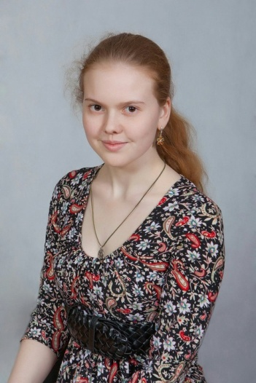
Gnesins Russian Academy of Music, Moscow, Russia
Teacher: Pavel Dombrovsky.

First Stage

W. A. Mozart Sonata No. 11 in A major K331, 1st mvt. (6’30’’)
F. Chopin Etude No. 5 in E minor Op. 25 (3’30’’)
F. Chopin Nocturne No. 1 in B major Op. 32 (4’30’’)
M. de Falla Ritual Dance of Fire (3’30’’)

Final Stage

I. J. Paderewski Song of the Travelar” (Chant du voyageur) No. 3, 4 Op. 8 (5’30”)
F. Chopin Nocturne No. 1 in C-Sharp minor Op. 27 (5’)
F. Chopin Mazurkas No. 2 in A-Flat major Op. 59, No. 2 in F minor Op. 63 (4’)
F. Chopin Ballade No. 2 in F Major Op. 38 (7’30”)
N. K. Medtner Forgotten Melodies I, Op. 38, No. 7 Danza Silvestra, No. 8 Alla Reminiscenza (7’)
S. Prokofiev Sonata No. 3 in A Minor Op. 28 (7’30”)
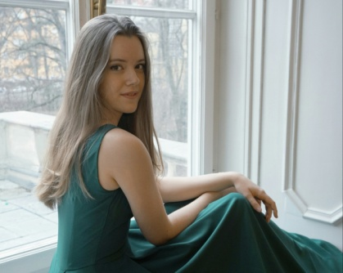
12. Kosanović, Jovana (14. 11. 1997), Serbia
University of Music and Performing Arts, Graz, Austria
Teacher: Milana Chernyavska

First Stage

W. A. Mozart 10 Variations on Gluck's Ariette Unser dummer Pöbel meint - (11’)
J. Rodrigo Seguidillas del Diablo, from Cuatro Estampas Andaluzas - (4’)
F. Liszt Transcendental Etude No. 12, Chasse-neige - (5’)

Final Stage

B. Bartok The Night's Music, from Out of Doors - (6’)
M. Ravel Sonatine - (11’)
Modéré
Mouvement de menuet
Animé
K. Szymanowski Variations in B-flat minor Op. 3 - (11’)
F. Liszt Legende No. 2, St. François de Paule marchant sur les flots, S. 175/2 - (8’)

13. Köveš, Sara (14. 09.1998), Slovenia
Academy of Music, Ljubljana, Slovenia
Teacher: Aleksandar Serdar

First Stage

L. van Beethoven Sonata Op. 27 No. 1, 1st mvt. - (5’30’’)
F. Chopin Etude Op. 10 No. 12 - (2’50’’)
A. Ginastera Danzas Argentinas - (8’)

Final Stage

F. Chopin Polonaise-Fantasie Op. 61 (11’)
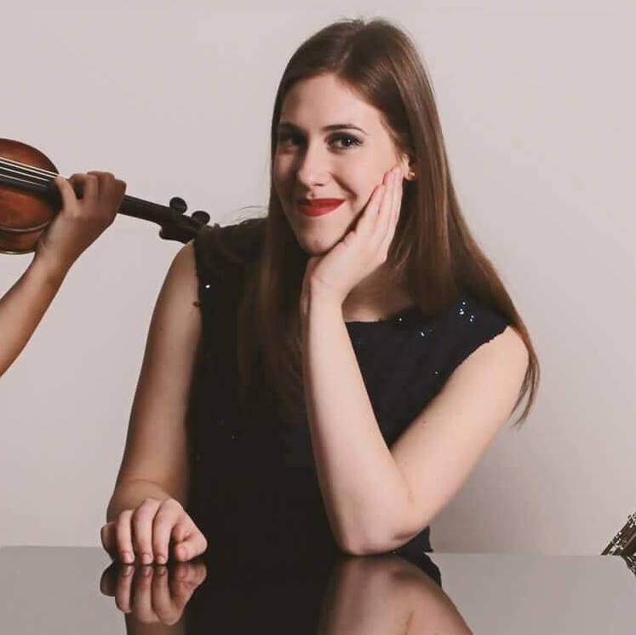
R. Schumann Kreisleriana, Op. 16 - (29’)

14. Ma, Catherine (29. 05. 1998), Canada
Juilliard School, New York City
Teacher: Julian Martin

First Stage

F. Chopin Etude Op. 10, No. 5 - (2’)
L. v. Beethoven Sonata Op. 2, No. 3, 1st mvt. - (7’)
E. Granados Danzas Españolas No. 5 - (3’)
F. Chopin Polonaise, Op. 53 - (7’)
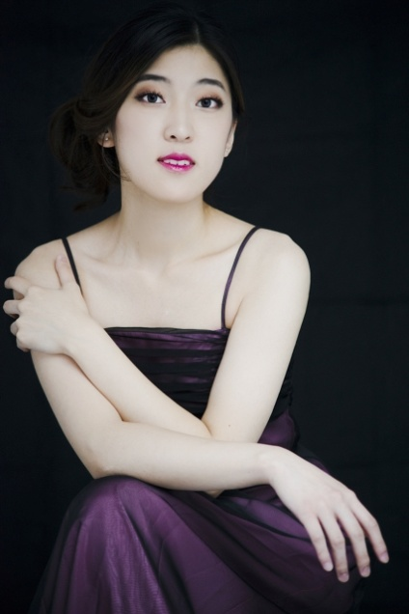
Final Stage:

F. Chopin Sonata, Op. 35 - (21’)
Ballade, Op. 52 No. 4 - (12’)
15. Opanasenko, Filipp A. (02. 09. 1995), Russia
Tchaikovsky Conservatory, Moscow, Russia
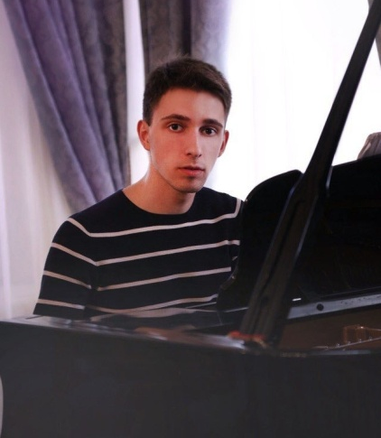
Teacher: Dmitry Kaprin

First Stage

F. Chopin Etude, Op. 10 No. 4 - (2’20’’)
L. v. Beethoven Sonata, Op. 26, 1st mvt. - (8’)
J. Turina Op. 84
Fiesta de las calderas - (4’)
Circulos ritmicos - (1’30’’)
Invocación - (4’)
Seguiriya – (2’)

Final Stage

J. S. Bach Toccata e- moll - (6’)
J. Brahms Rapsodie, Op. 79 No 1 & 2 - (14’)
S. Prokofiev Sonata in A minor, No. 3 - (7’)
16. Ovcharenko-Pieshkova, Olena (16. 03. 1996), Ukraine
Kiev Conservatory, Kiev, Ukraine
Teacher: Yuri Kot

First stage

J. Haydn Sonata No.60 in C major, Hob. XVI.50, 1st mvt - (6’)
F. Chopin Etude in A minor, Op 25 No. 11 - (4’)
Manuel de Falla Danse des voisins (seguidillas) - (3’20’’)
D. Shostakovich Prelude & Fugue in D-flat major - (4’40’’)

Final Stage

J.S.Bach Prelude & Fugue, WTC:II, No.1 in C Major, BWV 870 -(4’30’’)
F. Chopin Fantasie in F minor, Op 49 - (14’)
F. Liszt Rhapsodie espagnole, s.254 - (15’)

17. Palurović, Sofija (10. 07. 1997), Serbia
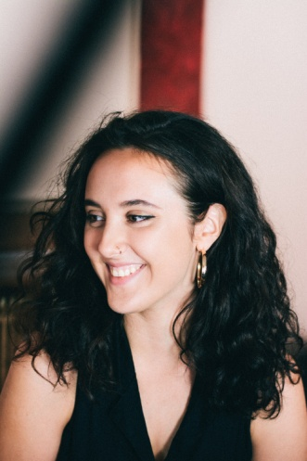
University of Music and Performing Arts, Mdw, Vienna, Austria
Teacher: Jasminka Stančul

First Stage

F. J. Haydn Sonata in A-flat major, Hob. XVI-46, 1st mvt. - (6’)S. Rachmaninoff Etude Tableaux, Op. 39 No. 1 in C minor - (3’30’’)
A. Ginastera Danzas Argentinas - (8’)

Final Stage

L. v. Beethoven Sonata in E major, Op. 109 - (23’)
S. Prokofiev Sonata in A minor, No. 3 - (8’30’’)
18. Park, Hyunmin (17. 04. 2002), Korea
Prayner Konservatorium Vienna, Austria
Teacher: Filimon Ginalis

First Stage

S. Rachmaninoff Etude Tableaux in D Major, Op. 39 No. 9 - (5’)
M. de Falla Danza del Terror - (2’)
J. Haydn Sonata in C major, Hob. XVI/48, Nr. 58, 2nd mvt. - (3’)
F. Chopin Sonata in B minor, Op. 58 No. 3, 4th mvt. -(5’)

Final Stage

M. Mussorgsky Pictures at an Exhibition - (30’)

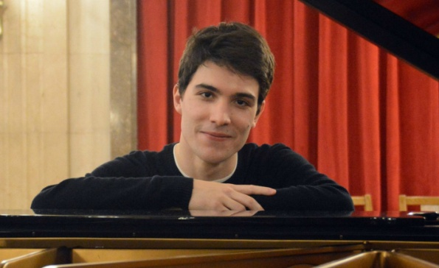
19. Radić, Viktor (16. 01.1996), Serbia
Academy of Music, Ljubljana, Slovenia
Teacher: Tatjana Ognjanovič

First Stage
A. Soler Sonata in D minor, R. 102 - (4’)
Sonata in F major, R. 6 - (4’)
W. A. Mozart Sonata No. 12 in F major, K. 332, Allegro - (5’)
J. Matičič Etude, Op. 30 No. 2 - (2’)
F. Mendelssohn / S. Rachmaninoff Scherzo from A Midsummer Night’s Dream - (4,5’)

Final Stage
W. A. Mozart Sonata No. 12 in F major, K. 332 - (15’)
Allegro
Adagio
Allegro assai
F. Chopin Mazurkas, Op. 56 - (12’)
Allegro non tanto
Vivace
Moderato
Ballade No. 2 in F major, Op. 38 - (8’)
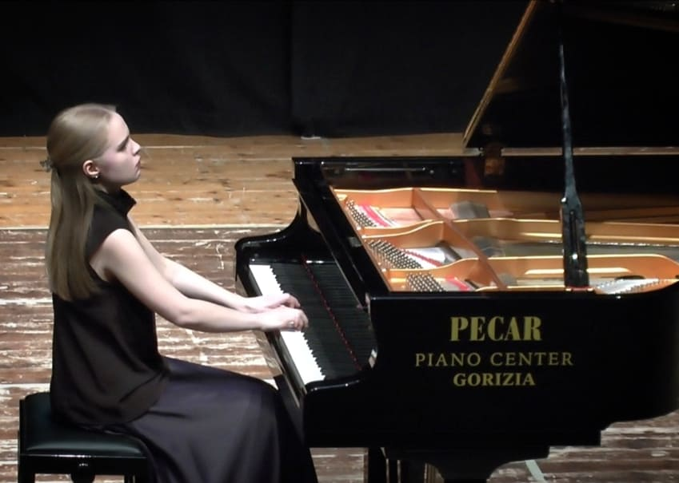
20. Rapatsevich, Olga (28. 01. 1997), Russia
Gnessin Russian Academy of Music, Moscow, Russia
Teacher: Pavel Dombrovsky

First Stage

L. v. Beethoven Sonata No. 7 (Op. 10 No. 3), 1st mvt. - (5’15’’)
F. Liszt Transcendental Etude No. 10 – (4’40’’)
E. Granados Allegro de concierto, Op. 46 – (8’)

Final stage

F. Liszt »Les cloches de Genève« - (6’20’’)
»Au bord d'un source« - (3’20’’)
J. Brahms Capriccio Op. 76 No.1 - (3’20’’)
Capriccio Op. 76 No.2 - (3’30’’)
Intermezzo Op. 76 No.6 - (3’45’’)
N. Medtner »Canzona matinata« - (4’15’’)
»Sonata Tragica« - (9’30’’)
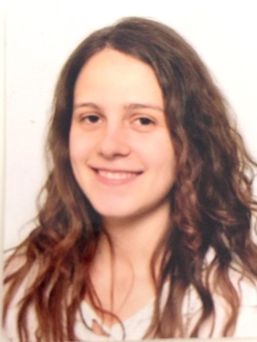
21. Serafimović, Milica (05. 02. 1999), Serbia
Academy of Music, Belgrade, Serbia
Teacher: Aleksandar Šandorov

First Stage

F. J. Haydn Sonata in C minor, Hob. XVI:20, 1st mvt. - (4’)
A. Soler Sonata in D-flat major - (3’)
F. Chopin Etude in F major, Op. 10 No. 8 - (2’45’’)
P. I. Tchaikovsky Dumka in C minor, Op. 59 - (9’)

Final Stage

L. v. Beethoven Sonata in E major, Op. 109 - (20’)
P. I. Tchaikovsky October from The seasons, Op. 37b - (4’)
R. Schumann Papillons, Op. 2 - (15’)
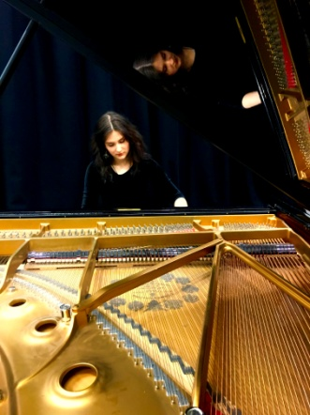
22. Tamkeviciute, Marija (08. 04. 2000), Lithuania
Hochschule für Musik Franz Liszt, Weimar, Germany
Teacher: Gerlinde Otto

First Stage

L. v. Beethoven Sonata in D major, Op 10 No. 3, 1st & 2nd mvts. - (11’)
I. Albeniz »Suite Española«, »Asturias« - (5’)
F. Liszt Grandes Etudes de Paganini, N0. 3 La Campanella - (4’)

Final Stage

F. Liszt Années de Pèlerinage II ((Italie) Suplement, S. 162): Venezia e Napoli - (18’)
S. Rachmaninoff Variations on a Theme of Corelli, Op. 42 - (19’)

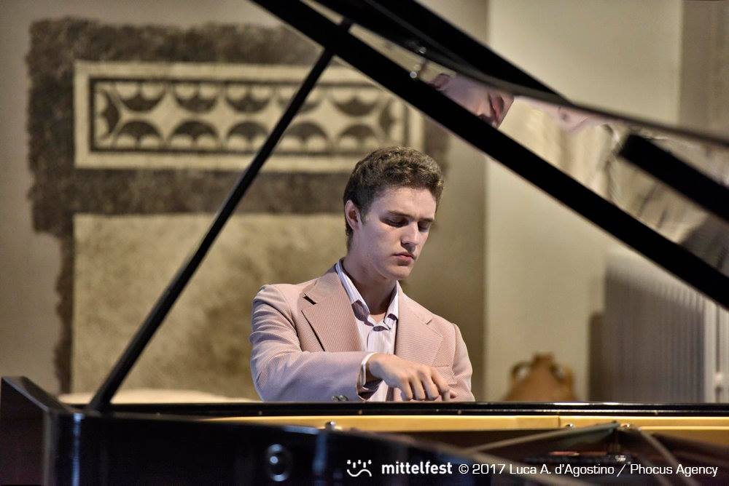
23. Tashko, Kostandin (17. 12. 1997), Albania
Conservatorio di Musica Giuseppe Tartini, Trieste, Italy
Teacher: Teresa Trevisan

First Stage - (20’)

S. Prokofiev Etude, Op. 2 No. 1
L. v. Beethoven Sonata, Op. 31 No. 2
A. Ginastera Danza de La Moza Donosa, from Danzas Argentinas, Op. 2 No. 2
A. Scriabin Sonata No. 5 in F-sharp major, Op. 53

Final Stage - (40’)

F. Liszt Sonata in B minor
M. Ravel La Valse

24. Voloshyna, Veronika (20. 11. 1995), Ukraine
University of Music Franz Liszt, Weimar, Germany
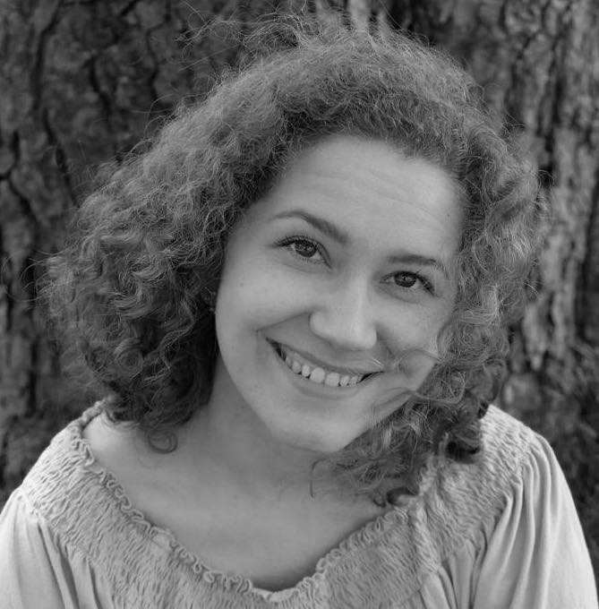
Teacher: Grigory Gruzman

First Stage

F. Liszt La lugubre gondola, II, S.200 - (6’)
F. Chopin Etude, Op.10 No. 8 - (2’40’’)
W. A. Mozart Sonata in D major, K. 576, 2nd & 3rd mvts. - (9’)
A. Ginastera Danza del gaucho matrero, Op. 2 No. 3 - (3’)

Final Stage

D. Shostakovich Prelude & Fugue in C Major, Op. 87 - (5’)
F. Chopin Ballade No. 1, Op. 23 - (9’)
D. Shostakovich Prelude & Fugue in A major, Op. 87 - (4’)
S. Prokofiev Sonata in D minor, Op. 14 - (18’)
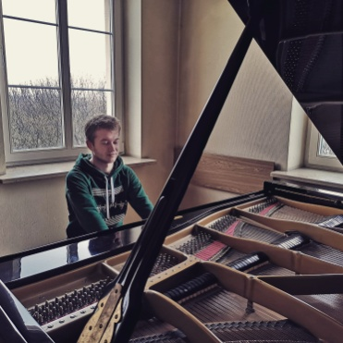
25. Vorobets, Oleksiy (15. 07. 1998), Ukraine
Academy of music, Kraków, Poland
Teacher: Marian Sobula

First Stage
F. Chopin Nocturne, Op. 9 No. 1 - (6’)
L. v. Beethoven Sonata, Op.81a, No. 26, 1st mvt. - (6’)
S. Rachmaninov Études-Tableaux, Op. 33 No. 7 in E-flat major- (2’)
I. Albeniz Suite Española, Op. 47 - Asturias (Leyenda) - (6’)

Final Stage

J. S. Bach Prelude & Fugue, WTC:I, No. 21 in B-flat major - (3’30’’)
F. Schubert Impromptu, Op. 90 No. 2 - (5’)
R. Schumann Kinderszenen, Op. 15 - (18’)
F. Chopin Etude, Op. 10 No. 8 - (2’30’’)
S. Prokofiev Sonata, Op. 28 No. 3 - (7’)
26. Vuković, Iva (29. 03. 2000), Serbia
Faculty of Music in Belgrade, Serbia
Teacher: Aleksandar Serdar

First stage

L. v. Beethoven Sonata in C major, Waldstein, Op. 53 No. 21, 1st mvt., Allegro con brio - (8’)
F. Liszt La Campanella - (5’)
A. Ginastera Danzas Argentinas, Op. 2 - (7’)

Final Stage

R. Schumann Symphonic Etudes, Op. 13 - (22’)
F. Chopin Fantasie in F minor, Op. 49 - (13’)

27. Yang, Xiaowei (31. 07. 1998), China
Hochschule für Musik, Würzburg, Germany
Teacher: Ana Mirabela Dina

First stage

L. v. Beethoven Sonata in C major, Op.2, No.3, 1st mvt. - (11’)
F. Liszt Paganini Etude No. 2 in B-flat major - (6’)
H.Villa Lobos Valsa Da Dor - (6’)

Final stage

J. Brahms Ballades in D major, Op. 10 No.2 & in B major, Op. 10 No. 4 - (15’)
F. Chopin Fantasie in F minor, Op. 49 - (14’)
A. Ginastera Suite De Danzas Criollas - (8’)

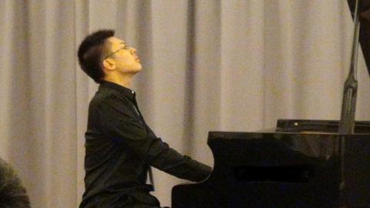
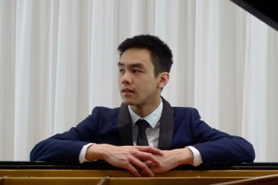
28. Zhang, Alex (07. 06. 1995), Australia
Würzburg Hochschule für Musik, Würzburg, Germany
Teacher: Inge Rosar

First Stage

S. Rachmaninov Etudes Tableaux, Op. 39 No. 3 in F sharp minor - (3’)
L. v. Beethoven Sonata No. 18 in E flat Major, Op. 31 No.3 - (11’)
I. Allegro
II. Scherzo. Allegretto vivace
I. Albéniz Triana from Iberia Book II - (5’30’’)

Final Stage

M. Ravel Miroirs - (30’)

29. Zhuri, Adelajd (06. 03. 1998), Albania
Conservatorio di Musica Giuseppe Tartini, Trieste
Teacher: Teresa Trevisan

First Stage

L. v. Beethoven Sonata Waldstein Op. 53, No. 21, 1st mvt - (9’)
C. Debussy Etude No. 9 - (4’)
H. Villa-Lobos Bachianas Brasileiras No.4 1 prelude (introduction) -(3’)
C. Debussy L'isle joyeuse (6’)

Final Stage

M. Clementi Sonata Op. 40, No.2 - (16’)
F. Liszt Tarantella - (10’)
Glinka/Gryaznov Valse fantasie (10’)

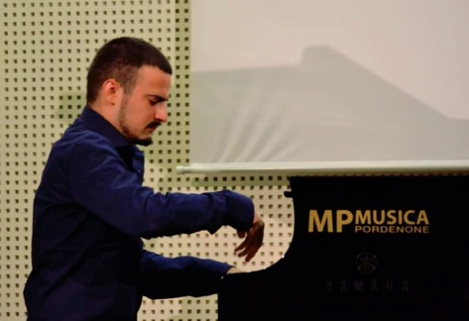
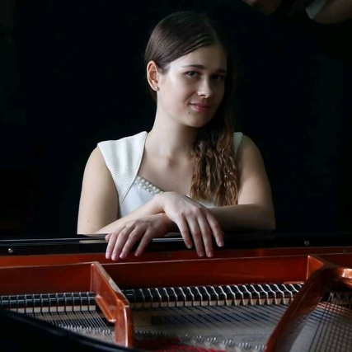
30. Zidarić, Jelena (21. 06. 1995), Serbia
University of Music, Belgrade, Serbia
Teacher: Branko Penčić

First Stage

L. v. Beethoven Sonata Op. 31 No. 1, 1st mvt. - (6’)
S. Rachmaninoff Etude tableaux Op. 39 No. 8 - (4’)
E. Lecuona Malagueña from Suite Andalusia - (5’)

Final Stage

A. Scriabin Preludes Op. 11 - (33’)

